Assignment 9A
Sumedh Bagade
Package login webapp from github on master and Deploy it to to tomcat server on slave
Steps:
1. Create two EC2 instances. One will be our jenkins master and other will be slave. We will package webapp on master using maven. This war file we will archive to jenkins and then copy it to slave using artifact archive plugin.
2. Install Java 17, apache tomcat 10, git and Maven on jenkins master. Configure Maven by defining environment variables in /root/.bash_profile
3. Install Java 17, apache tomcat 10 on the second EC2 instance and start apache tomcat. We will deploy our war package here in /mnt//apache home/webaps. We also need to create remoting directory /mnt/project. Then modify permission to /mnt directory so ec2-user has write and execute access.
4. Configure jenkins and create account.Then Configure maven in jenkins. Go to manage jenkins > tools > maven installations > add maven > give version name and define MAVEN_HOME
5. Create node 1. We are deploying webapp on this node.
6. We need to create two jobs. Job1 for packaging source code from github on master and archiving it to jenkins. Job2 for deploying war file to tomcat server on slave. We need to install artifact archive plugin first. So go to plugins > available plugins > artifact archive > install. Then restart jenkins.
7. Configure job1. Create custom workspace. We are running this job on master so restrict it so that it runs only on master. Add URL for github repo in source code management. For packaging add build step to invoke maven. In post build actions add Archive the artifacts. In files to archive give path for war file. As workspace is base directory so in our case this will be target/LoginWebApp.war . Save this job and move on to job2.
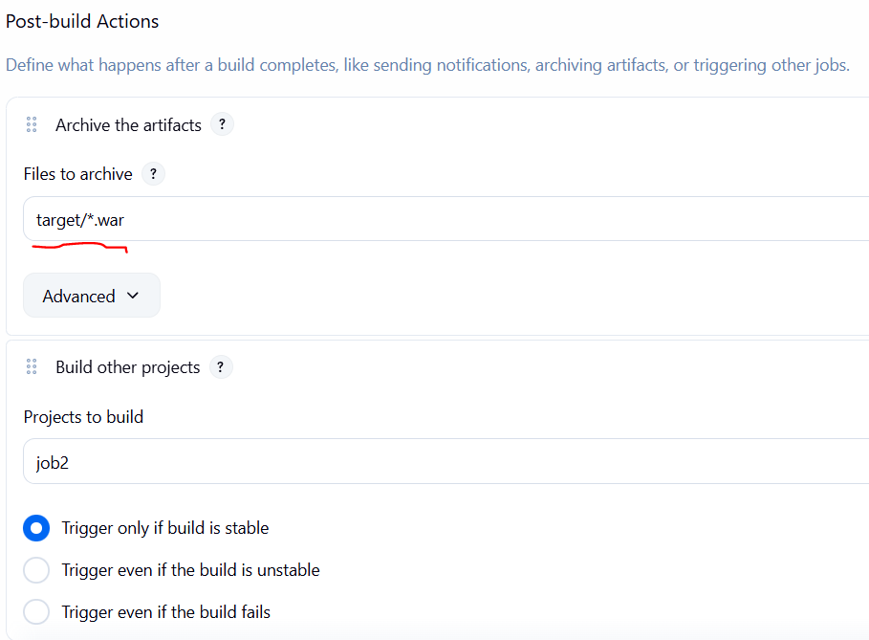
8. Configure job2. Create custom workspace. This job should run on slave so restrict it to salve node. In build steps add Copy artifacts from another project. Add details like shown below
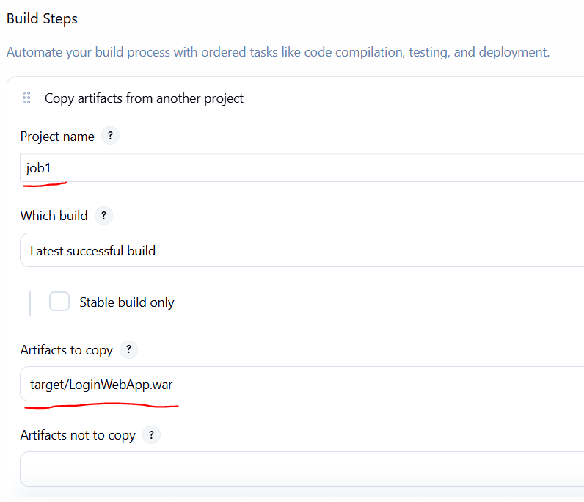
9. Add one more build step select Execute shell. Here we will copy war file to tomcat deployment directory.
echo "Deleting previous version"
rm -rf /mnt/webserver/apache-tomcat-10.1.52/webapps/LoginWebApp.war
echo "Deploying war file"
cp target/LoginWebApp.war /mnt/webserver/apache-tomcat-10.1.52/webapps/
10. Go back to job1. Select configure and add post build actions. Select build other projects and select job2 to run downstream of job1.
11. Run Job1 and job2 will automatically start after the build is completed. Access the webapp using public ip of slave.

Results :
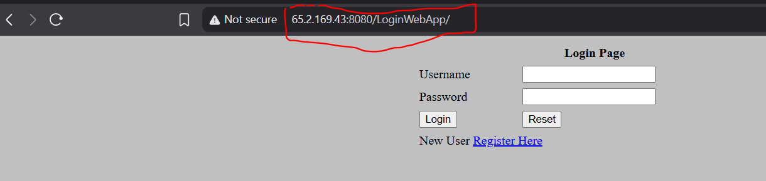

Assignment 9B
Sumedh Bagade
Package login webapp from github on master, Publish it to S3 bucket and Deploy it to tomcat server on slave
Steps:
1. Create two EC2 instances. One will be our jenkins master and other will be slave. We will package webapp on master using maven. This war file we will publish to S3 bucket and then deploy it to slave.
2. Create two IAM roles for ec2 instances so it can access S3. One role for master node with full S3 access and another for slave with read only S3 access. Apply these roles to respective ec2 instances.
3. Install Java 17, apache tomcat 10, git and Maven on jenkins master. Configure Maven by defining environment variables in /root/.bash_profile
4. Install Java 17, apache tomcat 10 on the second EC2 instance and start apache tomcat. We will deploy our war package here in /mnt//apache home/webaps. We also need to create remoting directory /mnt/project. Then modify permission to /mnt directory so ec2-user has write and execute access
5. Configure jenkins and create account.Then Configure maven in jenkins. Go to manage jenkins > tools > maven installations > add maven > give version name and define MAVEN_HOME
6. Go to AWS console and create general purpose S3 bucket “artifact-repo-sumedh”.
7. Go to jenkins dashboard and create node 1. We are deploying webapp on this node.
8. We need to create two jobs. Job1 for packaging source code from github on master and publishing it to S3. Job2 for deploying war file to tomcat server on slave.
9. Configure job1. Create custom workspace. We are running this job on master so restrict it so that it runs only on master. Add URL for github repo in source code management. For packaging add build step to invoke maven. Add one more build step and select execute shell. Write the script for publishing artifact to S3
aws s3 rm s3://artifact-repo-sumedh --recursive
aws s3 cp target/*war s3://artifact-repo-sumedh
8. Configure job2. Create custom workspace. This job should run on slave so restrict it to salve node. In build steps add and select Execute shell. Here we will copy artifact from S3 and deploy it to tomcat server.
echo "Removing older version"
rm -rf /mnt/webserver/apache-tomcat-10.1.52/webapps/LoginWebApp.war
echo "Downloading artifact"
aws s3 cp s3://artifact-repo-sumedh/LoginWebApp.war /mnt/webserver/apache-tomcat-10.1.52/webapps/
10. Go back to job1. Select configure and add post build actions. Select build other projects and select job2 to run downstream of job1.

Results:
